UX Check Results

# Heuristic: Match between system and the real world

# Severity: 0

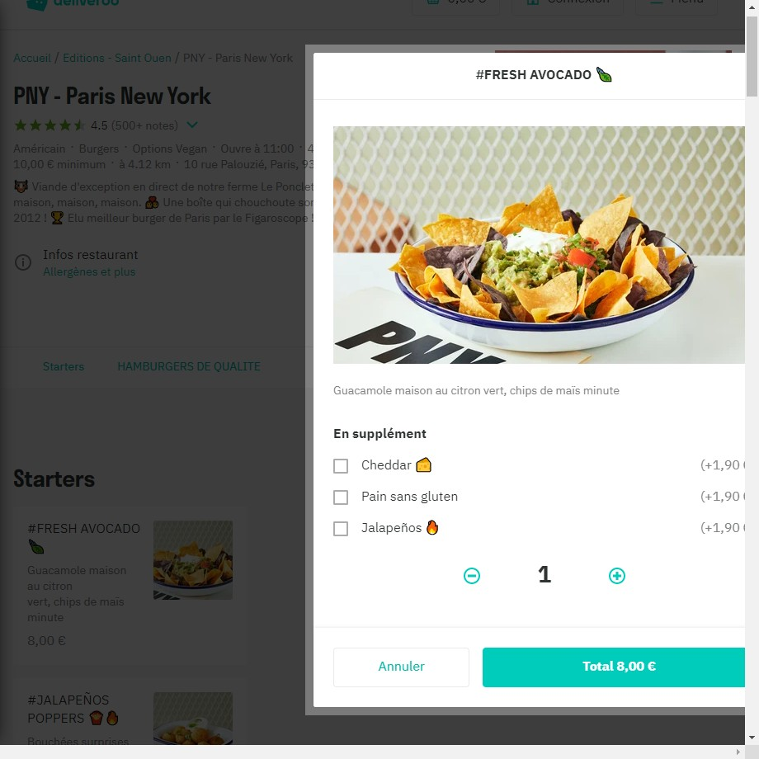

# Notes:

Images and videos are relevant and meaningful. No unrelated stock photos of models. There are high-quality screenshots, videos or photos of the products and services.

# Heuristic: Visibility of system status

# Severity: 3

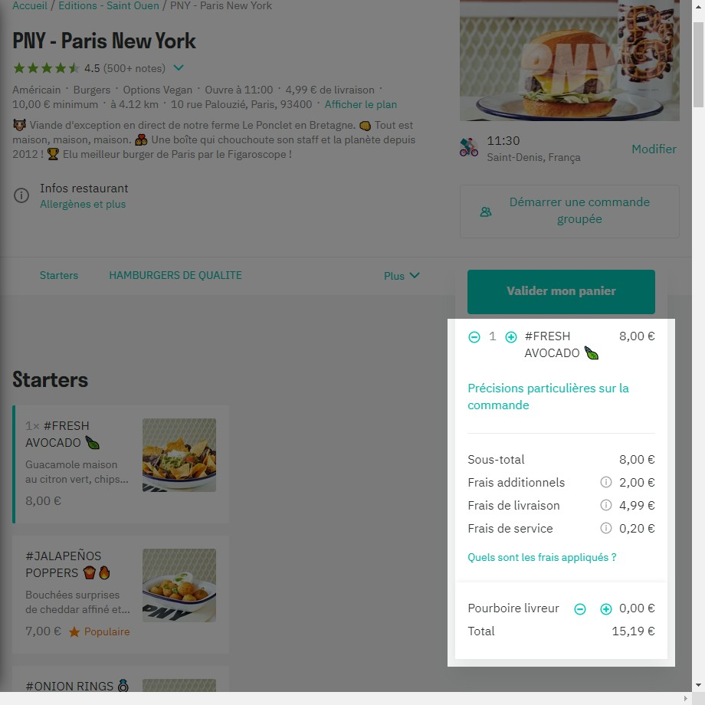

# Notes:

When you select “Fresh Avocado”, the price on basket is 8,00€ and automatically rises to 15,19€ with all service and delivery fees.

# Recommendation:

Transparent pricing. Prices are clearly displayed. There are no hidden costs or surprises in the terms.

# Heuristic: User control and freedom

# Severity: 0

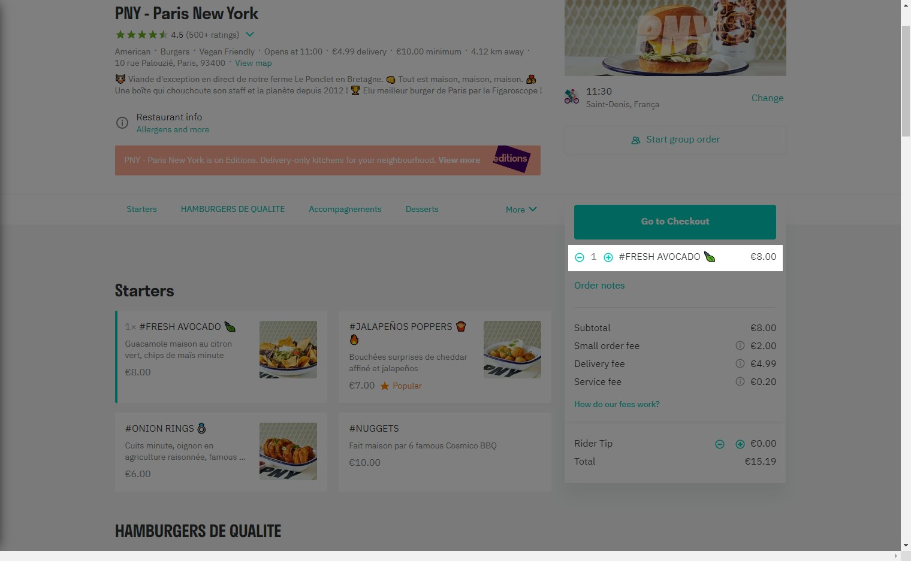

# Notes:

Easy to fix the error of the selected product.

# Heuristic: Consistency and standards

# Severity: 1

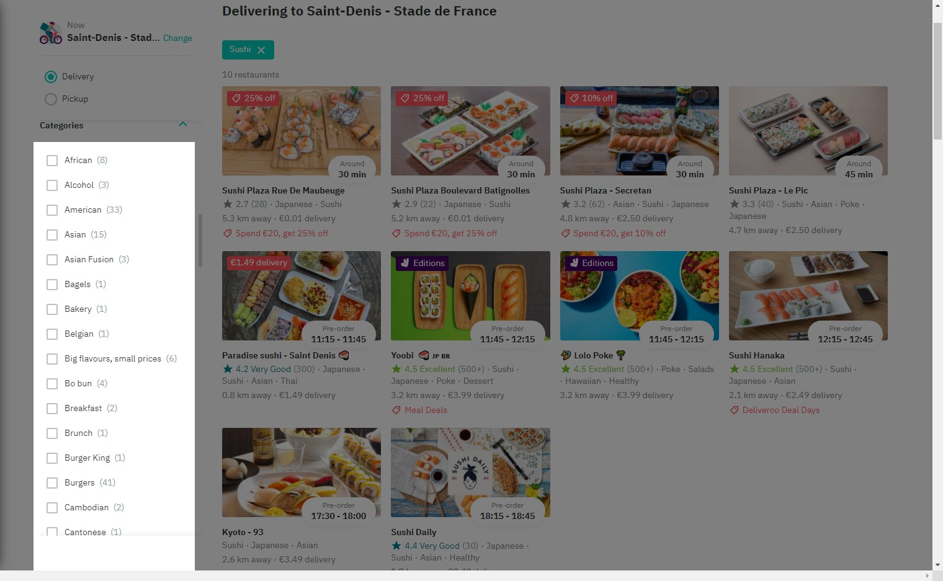

# Notes:

Alphabetical sorting is used only when there are no better alternatives, such as grouping items into descriptive, related groups.

# Recommendation:

Too many groups created in the categories. It is confusing for the customer to choose.

# Heuristic: Error prevention

# Severity: 1

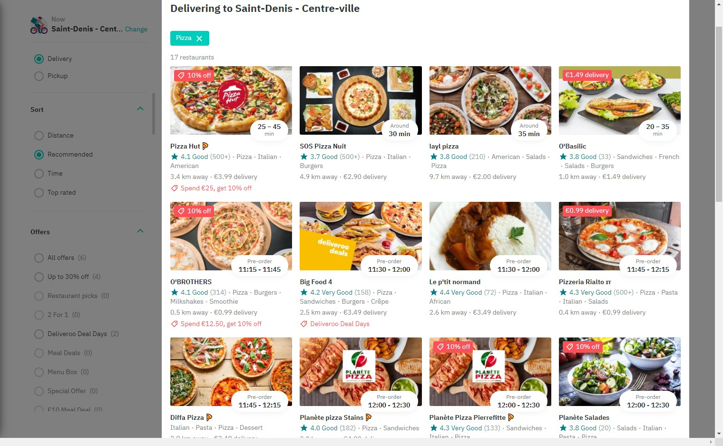

# Notes:

When the product filter is changed, there are some that should not appear in this category.

# Recommendation:

Check the selected category for each platform product.

# Heuristic: Recognition rather than recall

# Severity: 0

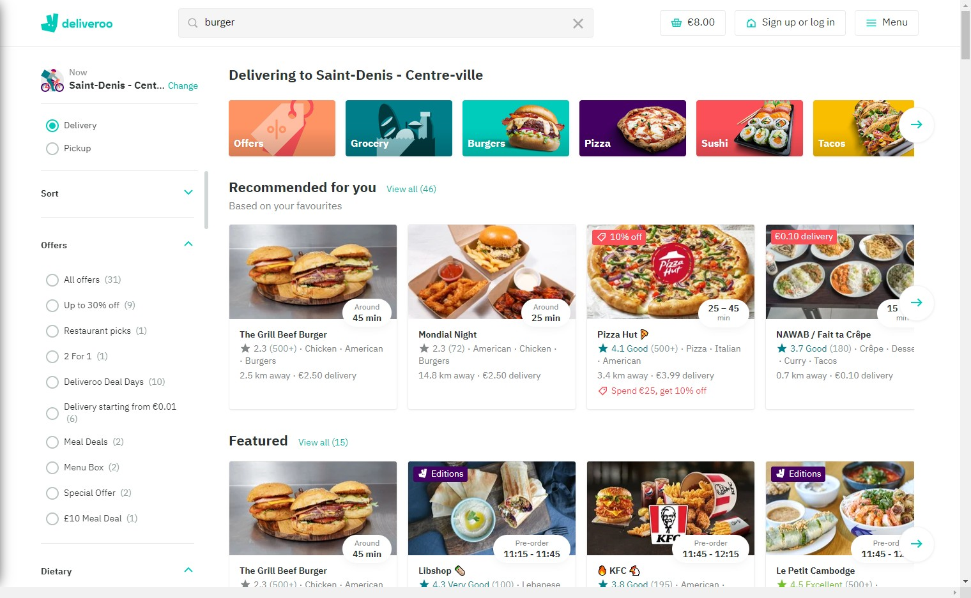

# Notes:

The client should not have to remember information from one part of the dialogue to another. Instructions for use of the system should be visible or easily retrievable whenever appropriate.

# Heuristic: Flexibility and efficiency of use

# Severity: 1

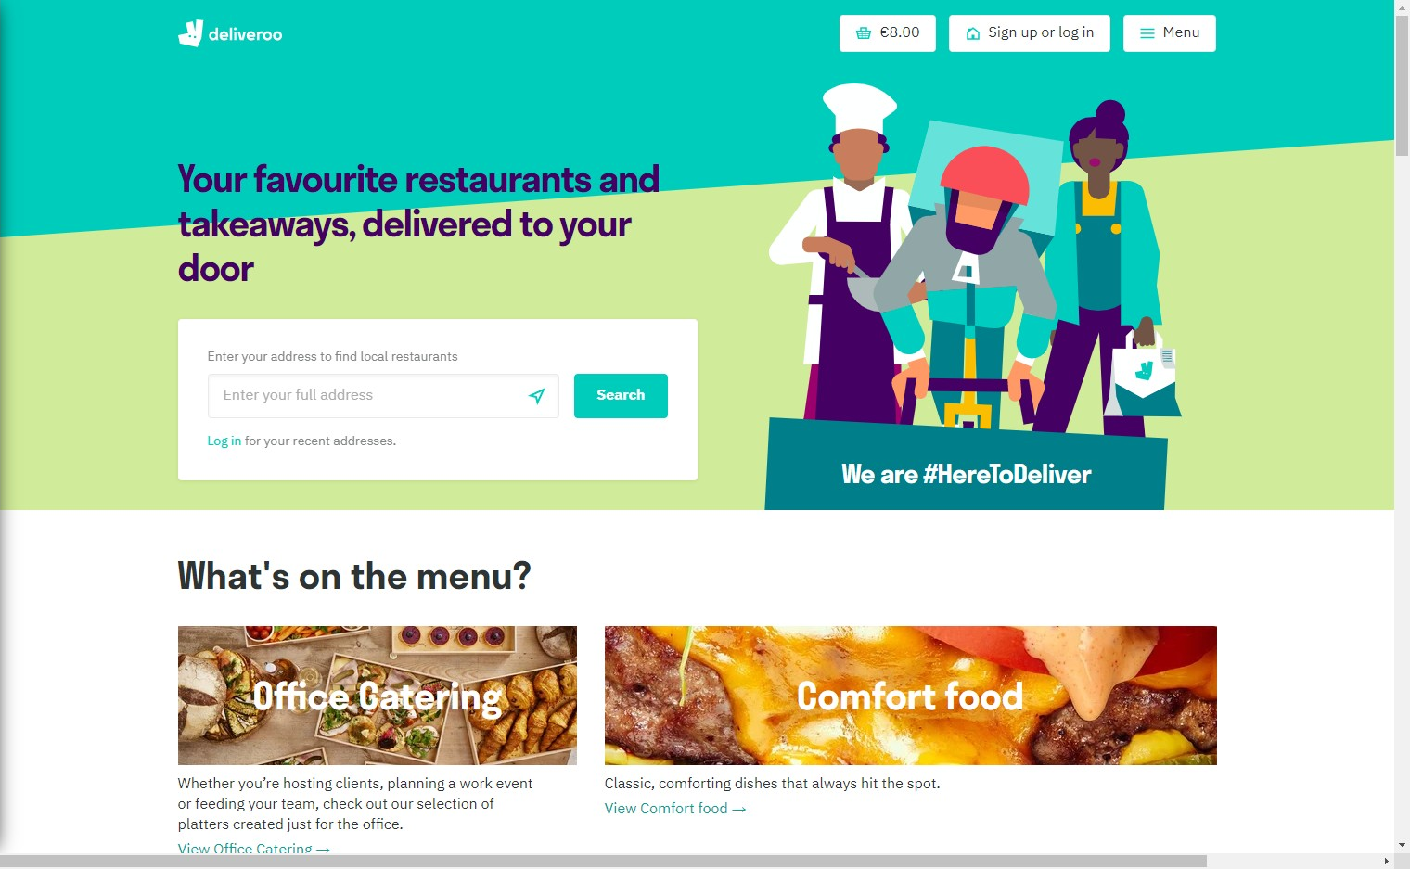

# Notes:

There is no accelerators on page.

# Recommendation:

The interaction for the expert user such that the system can cater to both inexperienced and experienced users. Allow users to tailor frequent actions.

# Heuristic: Aesthetic and minimalist design

# Severity: 2

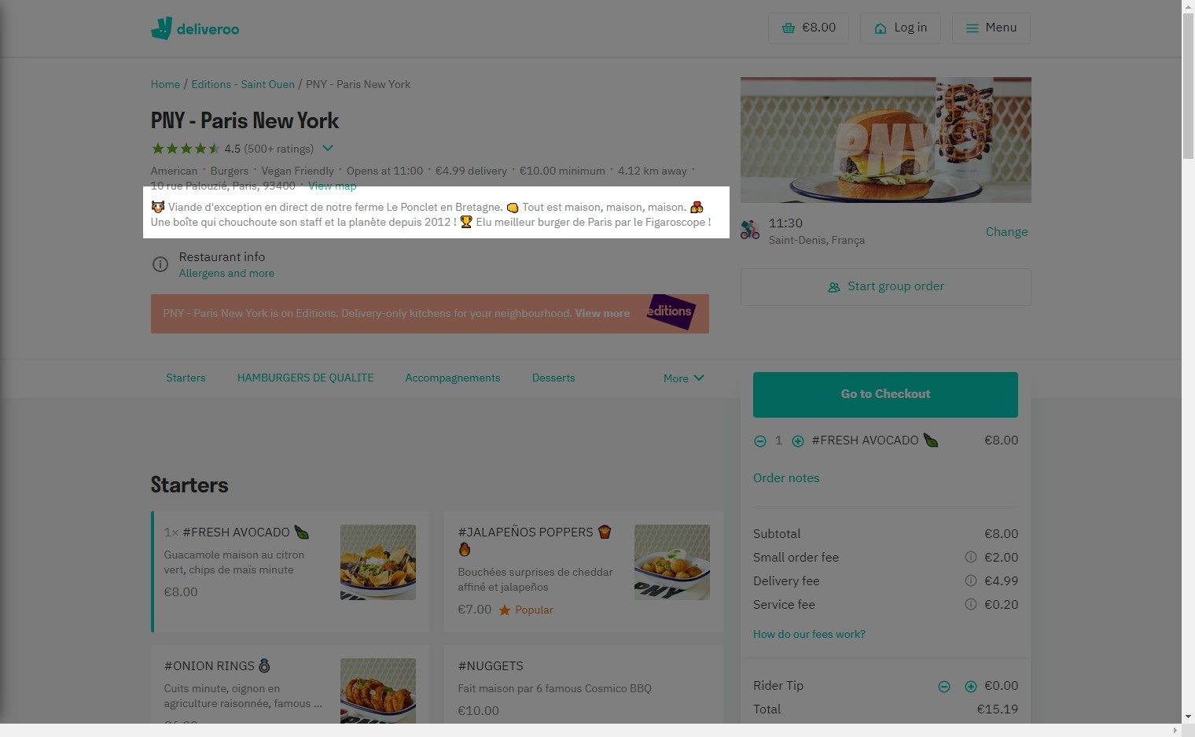

# Notes:

The minimum text can be more assertive, thus making the text confusing without the need for emojis between them.

# Recommendation:

Understanding that these images can speak for themselves, there is little need to further explain what products are beyond the essentials.

# Heuristic: Help recognize &amp; recover from errors

# Severity: 0

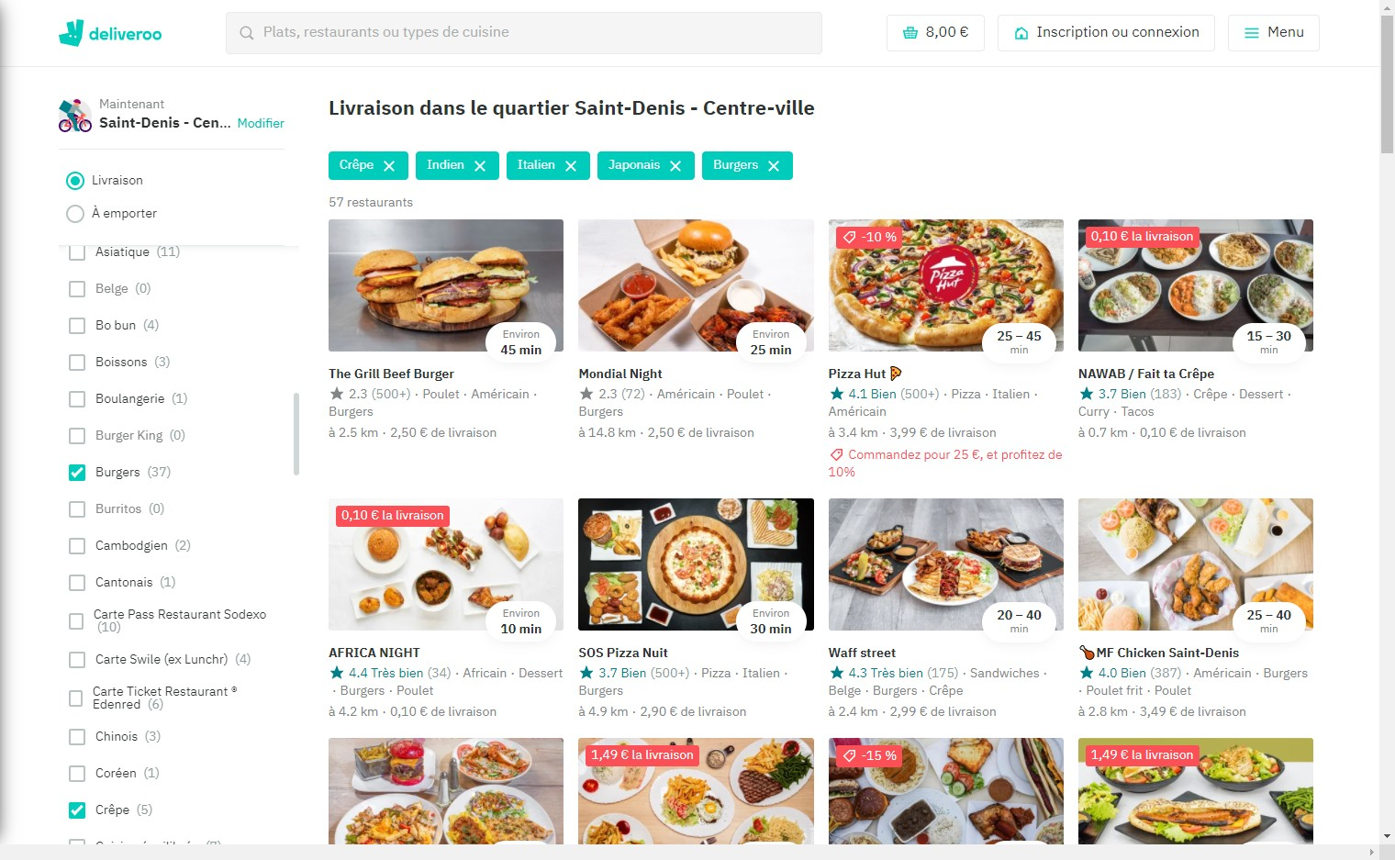

# Notes:

After a long search test through filters and changing cities, it's difficult to make an error on the website.

# Heuristic: Help and documentation

# Severity: 2

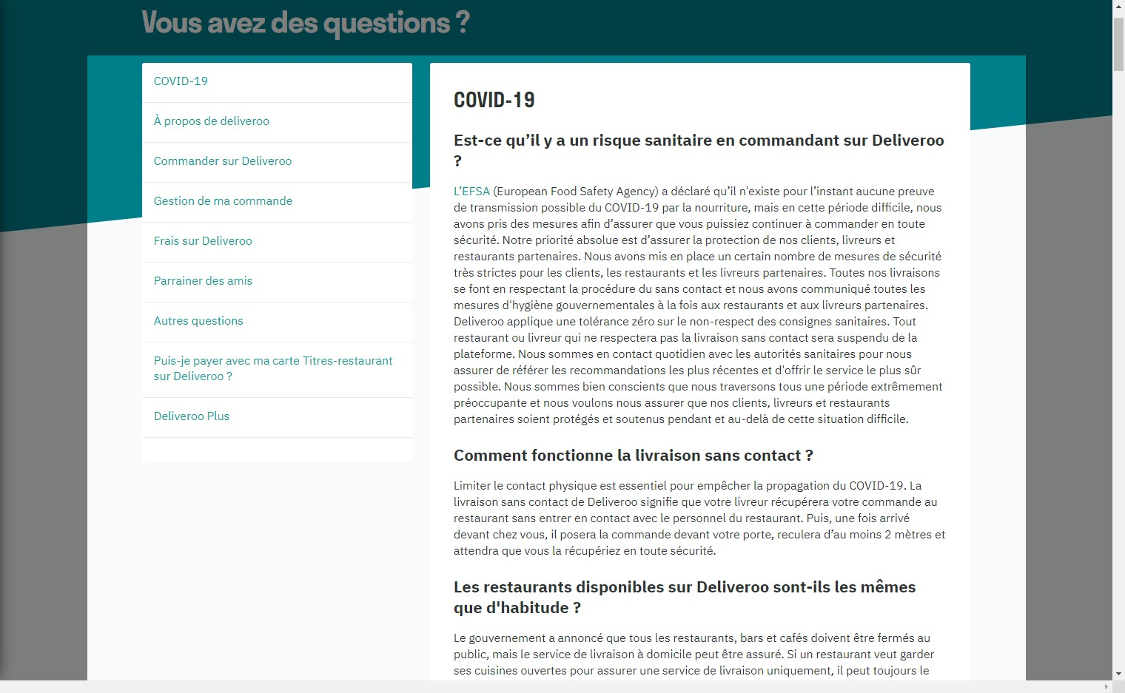

# Notes:

List of FAQs too long and without search option. Any necessary help documentation should be easy to search, focused on the user's task, list concrete steps to be carried out, and not be too large.

# Recommendation:

Shorten the list and prioritize the questions that appear more regularly.